Steps to install Maven via Eclipse (Maven as eclipse plugin)

There are two ways to install [***Maven***](https://toolsqa.com/maven/maven-introduction/). One which is a little difficult than the other is installing Maven through the command line. And the other easy way out is installing Maven within Eclipse. In this chapter I will show ***How to Install Maven in Eclipse IDE*** and in case you face any issue during installation, you are most welcome to go for the other way which is the next chapter.

**Steps to Install Maven in Eclipse IDE**

1. *Click* on the ***Help*** from the top menu in ***Eclipse*** and select '*Install New Software*'.

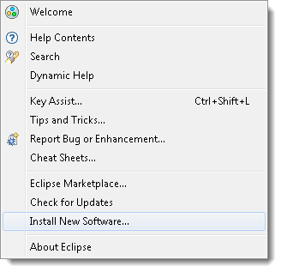

1. Click on the ***Add*** button on the newly opened window.

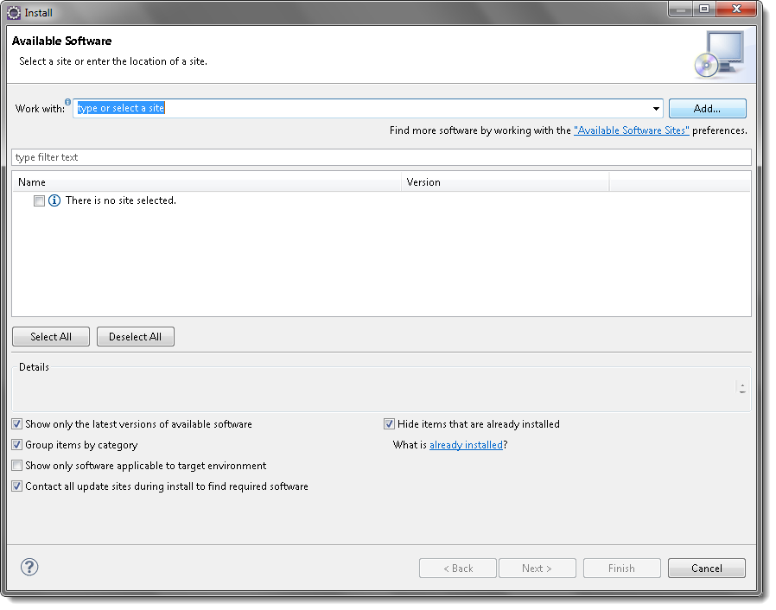

1. In the *Name box*, type '*Maven*' and in the *Location box*, type '*http://download.eclipse.org/technology/m2e/releases/*'

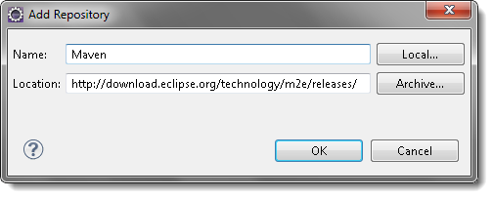

***Note****: The URL is the location where you can download the Maven for Eclipse*.

1. A *check-box* will appear in the pop window, ***Check*** the *check-box* and *click* on the ***Next*** button.

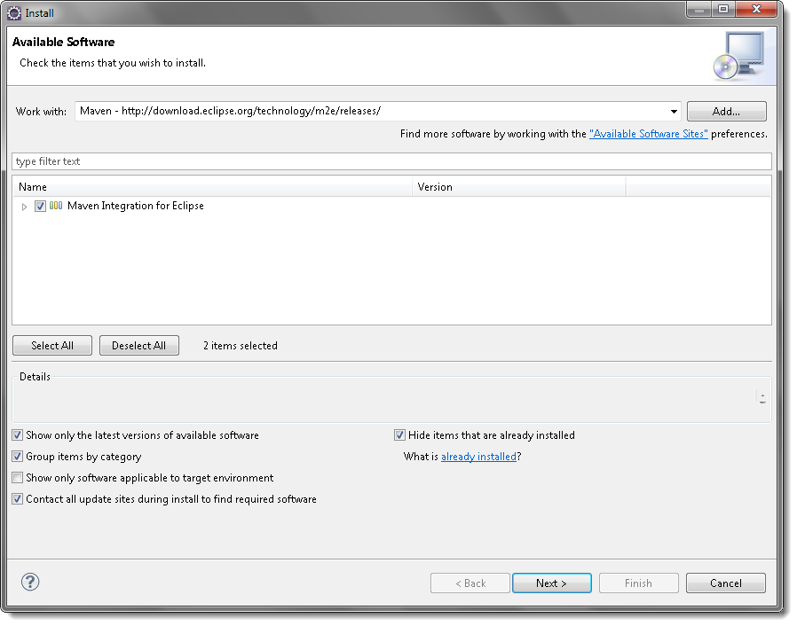

1. Please wait for some time and let the window complete its processing. It will not take long but 2 or 3 minutes.

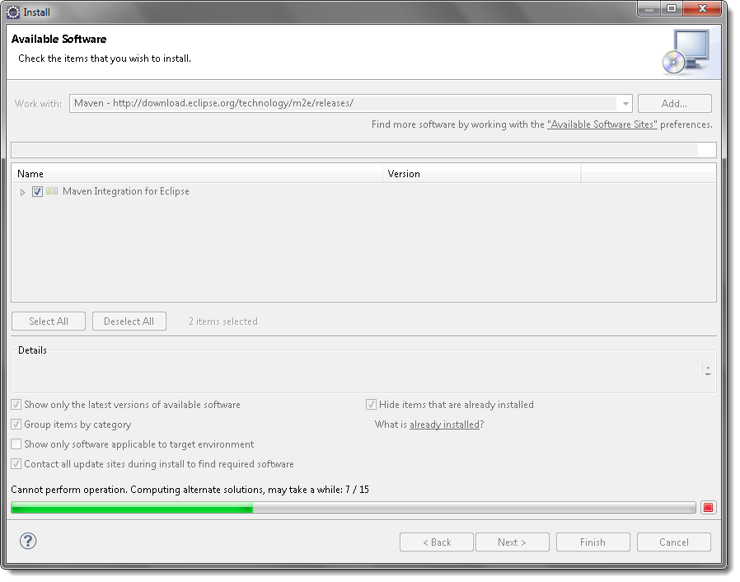

1. Keep the default settings and *click* on the ***Next*** button.

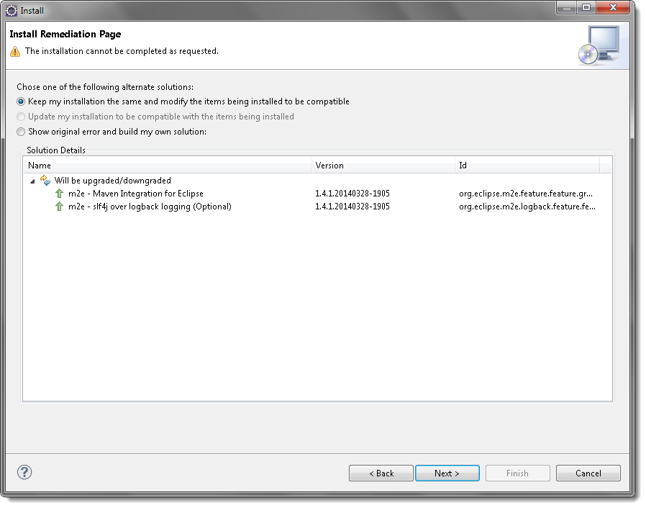

1. Accept the '*Terms and Conditions*' and move forward by clicking on the ***Finish*** button.

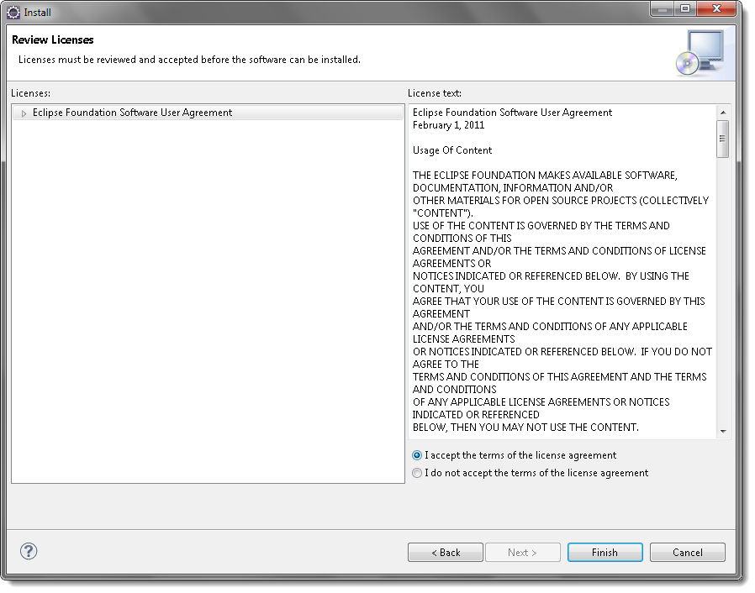

1. Wait while it finishes the installation.

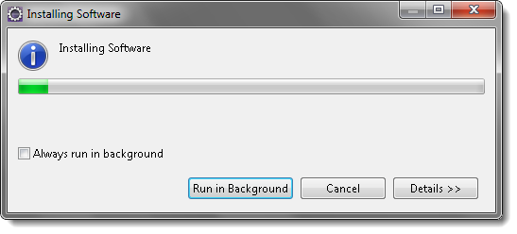

1. Once the installation is finished, it will ask you to *restart the Eclipse*. Please *click* on ***Yes***, so that changes can be reflected properly.

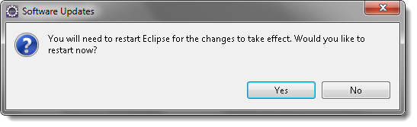

This is all for the Installation of Maven in Eclipse. The other way of installing the Maven is from Command-Line, the next chapter is all about that. So in case, your installation is done properly, please skip the next chapter.